# TFT 터치패널 – 좌표 인식

## 목표

2.4인치 TFT 터치패널의 좌표 개념 이해와 활용

## 회로도

## 실물

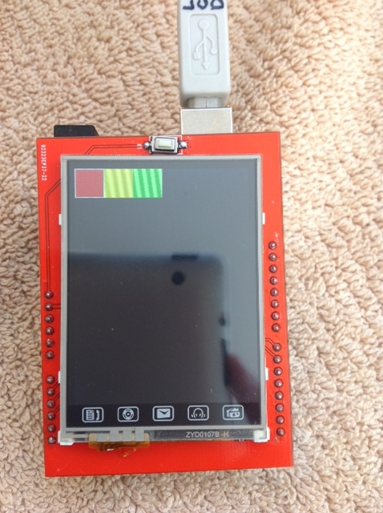

## 코드

#include "TFTLCD.h"

#include "TouchScreen.h"

//Duemilanove/Diecimila/UNO/etc ('168 and '328 chips) microcontoller:

#define YP A1 // must be an analog pin, use "An" notation!

#define XM A2 // must be an analog pin, use "An" notation!

#define YM 7 // can be a digital pin

#define XP 6 // can be a digital pin

//#define TS_MINX 150

#define TS_MINX 110

//#define TS_MINY 120

#define TS_MINY 200

#define TS_MAXX 920

//#define TS_MAXY 940

#define TS_MAXY 890

#define MINPRESSURE 10

#define MAXPRESSURE 1000

// For better pressure precision, we need to know the resistance

// between X+ and X- Use any multimeter to read it

// For the one we're using, its 300 ohms across the X plate

TouchScreen ts = TouchScreen(XP, YP, XM, YM, 300);

#define LCD_CS A3

#define LCD_CD A2

#define LCD_WR A1

#define LCD_RD A0

// optional

#define LCD_RESET A4

// Color definitions

#define BLACK 0x0000

#define BLUE 0x001F

#define RED 0xF800

#define GREEN 0x07E0

#define CYAN 0x07FF

#define MAGENTA 0xF81F

#define YELLOW 0xFFE0

#define WHITE 0xFFFF

TFTLCD tft(LCD_CS, LCD_CD, LCD_WR, LCD_RD, LCD_RESET);

#define BOXSIZE 40

#define PENRADIUS 3

int oldcolor, currentcolor;

void setup(void) {

Serial.begin(9600);

Serial.println("Coordinate Test!");

tft.reset();

tft.initDisplay();

tft.fillScreen(BLACK);

//Horizontal tiles

tft.fillRect(0, 0, BOXSIZE, BOXSIZE, RED);

tft.fillRect(BOXSIZE, 0, BOXSIZE, BOXSIZE, YELLOW);

tft.fillRect(BOXSIZE*2, 0, BOXSIZE, BOXSIZE, GREEN);

tft.drawRect(0, 0, BOXSIZE, BOXSIZE, WHITE);

currentcolor = RED;

pinMode(13, OUTPUT);

} // setup

void loop()

{

digitalWrite(13, HIGH);

Point p = ts.getPoint();

digitalWrite(13, LOW);

/*

Serial.print("Pressure p.z: ");

Serial.println(p.z);

Serial.print("X-coord p.x: ");

Serial.println(p.x);

Serial.print("Y-coord p.y: ");

Serial.println(p.y);

p.x = map(p.x, TS_MINX, TS_MAXX, 0, tft.width());

p.y = map(p.y, TS_MINY, TS_MAXY, 0, tft.height());

Serial.print("Calibrated X-coord mapped p.x: ");

Serial.println(p.x);

Serial.print("Calibrated Y-coord mapped p.y: ");

Serial.println(p.y);

*/

p.x = map(p.x, TS_MINX, TS_MAXX, 0, tft.width());

p.y = map(p.y, TS_MINY, TS_MAXY, 0, tft.height());

if ((p.x > -10) && (p.x < 15))

{

if (p.y < 30)

{

Serial.println("Home");

tft.drawString(20, 10, "Home", YELLOW, 3);

tft.drawVerticalLine (0, 15, 100, YELLOW);

}

else if (p.y < 100)

Serial.println("Headphone");

else if (p.y < 180)

Serial.println("Mail");

else if (p.y < 250)

Serial.println("Disc");

else if (p.y < 320)

Serial.println("Address");

} // if ((p.x > -10) && (p.x < 15))

pinMode(XM, OUTPUT);

pinMode(YP, OUTPUT);

//pinMode(YM, OUTPUT);

delay(1000);

// we have some minimum pressure we consider 'valid'

// pressure of 0 means no pressing!

/*

if (p.z > MINPRESSURE && p.z < MAXPRESSURE) {

if (p.y < (TS_MINY-5)) {

Serial.println("erase");

// press the bottom of the screen to erase

tft.fillRect(0, BOXSIZE, tft.width(), tft.height()-BOXSIZE, BLACK);

}

// turn from 0->1023 to tft.width

p.x = map(p.x, TS_MINX, TS_MAXX, 0, tft.width());

p.y = map(p.y, TS_MINY, TS_MAXY, 0, tft.height());

Serial.println(p.x);

Serial.println(p.y);

if (p.y < BOXSIZE) {

oldcolor = currentcolor;

if (p.x < BOXSIZE) {

currentcolor = RED;

tft.drawRect(0, 0, BOXSIZE, BOXSIZE, WHITE);

}

else if (p.x < BOXSIZE*2) {

currentcolor = YELLOW;

tft.drawRect(BOXSIZE, 0, BOXSIZE, BOXSIZE, WHITE);

}

else if (p.x < BOXSIZE*3) {

currentcolor = GREEN;

tft.drawRect(BOXSIZE*2, 0, BOXSIZE, BOXSIZE, WHITE);

}

else if (p.x < BOXSIZE*4) {

currentcolor = CYAN;

tft.drawRect(BOXSIZE*3, 0, BOXSIZE, BOXSIZE, WHITE);

}

else if (p.x < BOXSIZE*5) {

currentcolor = BLUE;

tft.drawRect(BOXSIZE*4, 0, BOXSIZE, BOXSIZE, WHITE);

}

else if (p.x < BOXSIZE*6) {

currentcolor = MAGENTA;

tft.drawRect(BOXSIZE*5, 0, BOXSIZE, BOXSIZE, WHITE);

}

if (oldcolor != currentcolor) {

if (oldcolor == RED) tft.fillRect(0, 0, BOXSIZE, BOXSIZE, RED);

if (oldcolor == YELLOW) tft.fillRect(BOXSIZE, 0, BOXSIZE, BOXSIZE, YELLOW);

if (oldcolor == GREEN) tft.fillRect(BOXSIZE*2, 0, BOXSIZE, BOXSIZE, GREEN);

if (oldcolor == CYAN) tft.fillRect(BOXSIZE*3, 0, BOXSIZE, BOXSIZE, CYAN);

if (oldcolor == BLUE) tft.fillRect(BOXSIZE*4, 0, BOXSIZE, BOXSIZE, BLUE);

if (oldcolor == MAGENTA) tft.fillRect(BOXSIZE*5, 0, BOXSIZE, BOXSIZE, MAGENTA);

}

}

if (((p.y-PENRADIUS) > BOXSIZE) && ((p.y+PENRADIUS) < tft.height())) {

tft.fillCircle(p.x, p.y, PENRADIUS, currentcolor);

}

}

*/

} // loop

## 결과

TFT LCD에 인쇄되어 있는 아이콘을 누르면 해당 아이콘의 이름이 시리얼 모니터에 출력.

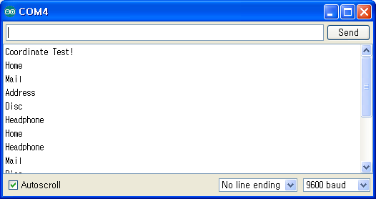

# 용어

# 참조

(2014.12.11 접근)